Stirling Swimming  Water Polo Section  July 2014 Newsletter | 

Dear all,

Well summer is here but Water Polo continues on and I hope some of you were able to watch some of the European Championships that were streamed live and also on Eurosport. If you didn’t watch – Serbia won the Men’s final against Hungary and Spain beat The Netherlands in the Women’s final.

Many of you will be involved in the Scottish Water Polo Camp at the University this weekend either playing or attending the Level 1 coaching course. I know that there are 3 sessions scheduled for the Sunday and the last one ends at 5.30pm – just when our normal session is about to start. I plan to have a games night – so I would hope everyone stays around. Also if any parents want to try the game – then bring your trunks/costumes and have a go.

The following Sunday 10 August 2014 – we will start preparations for the upcoming Scottish League games in September. I am looking for maximum attendance over the next 3 months. The provisional fixtures are at the end of this newsletter,

Match Reports

Scottish Under 16 Leagues (1999+)

Sunday 8 June 2014: Portobello 7 vs Stirling 11
Stirling recommenced their Scottish under 16 League campaign with a game against Portobello. The last fixtures were in March and the lack of match sharpness showed when the Team started poorly. Portobello took a quick 2 goal lead with poor defensive organisation from Stirling. On attack they were creating chances and got one back before Portobello scored another 2 to lead at the end of the quarter 4-1. Some harsh words from the coach were needed but this did not have any immediate affect when Portobello stretched their lead to 5-1. However, Stirling rallied and started controlling the game and importantly continued to convert their chances. They shut down many of the Portobello attacks in the quarter allowing them only 1 goal whilst scoring 3 of their own to end the half only trailing 5-4.

The momentum was with Stirling and they produced an excellent quarter of Water Polo when they shut out their opponents and scored 4 goals without reply. They had raised the pace of the game and were playing an excellent zone defence giving their opponents no clear shots at goal. Leading 8-5 going into the final period they kept control and stretched their lead to 10-5 before Portobello got back on the score sheet through a penalty. The game ended with a solid 11-7 win to Stirling.

Team (scorers) Elliot Harris (1), Aithnie Lawrence, Alexander Harris, Ewen Randfield (2), Lachlan Kelly, Lucy Tweedle, Mairead MacDonald, Lauren Dundee, Lewis Goldie (5), Calum Hope, Elliott Lawrence (2), Harry Gray (1), Reuben Bowman
Sunday 15 June 2014: Warrender 5 vs Stirling 5
After a good finish and win in the previous league outing against Portobello, Stirling took on another Edinburgh Team with hopes of continuing their unbeaten run in the League. It started well, and with just under a minute played, a very well worked move down the left and a cut across to the right, found an unmarked Stirling player to slot home a tidy finish. However, Warrender equalised almost immediately and both Teams found it difficult to create good scoring chances. The quarter ended 1 apiece. The 2nd quarter saw Warrender start quicker and they scored 2 goals within a couple of minutes. Stirling were fighting hard but they did not have the patience to work clear scoring opportunities. Their defence improved and their hard work was rewarded with a goal towards the end of the period. At the half, Warrender led 3-2.

The 3rd quarter saw Stirling start well and it was they who got 2 goals to take a narrow lead, however their opponents fought back with 2 of their own and this was turning out to be a very close and tense match. However, just as the period ended, Stirling thought they had levelled the game with a superb long range shot, however, the officials deemed the ball was released fractions after the buzzer and the goal was disallowed. Going into the 4th and final quarter, Stirling trailed 4-5. Warrender were on the defensive and Stirling were trying to get the important equaliser. This came with just over 3 minutes left in the game and both Teams were hesitant in attack ensuring that their opponents never got a further scoring opportunity.

A final score of 5 apiece keeps Stirling’s unbeaten run in the League going but it was a disappointing performance. After the summer, Stirling will take on Forth Valley and the other remaining unbeaten Team in the League, Dunfermline.

Team (scorers) Reuben Bowman, Keir Fairley, Alexander Harris, Ewen Randfield (1), Lachlan Kelly, Mairead MacDonald, Lauren Dundee, Lewis Goldie, Calum Hope, Elliott Lawrence (1), Harry Gray, Vincent Jozajtis (3), Elliot Harris

West District Under 18 Cup Final

Sunday 15 June 2014 – Stirling 15 vs Forth Valley 8
In front of a large and appreciative support Stirling played their very first cup final and nerves showed with hesitancy in defence allowing Forth Valley to take an early 2 goal lead. However, Stirling got quickly back in to the game and played the game at a pace that Forth Valley found difficult. They scored 4 unanswered goals to end the quarter 4-2 in the lead. The 2nd quarter saw Stirling play some excellent polo and they dominated the opposition with fast counter attacks and scored a further 4 goals before Forth Valley got back on the score sheet. Stirling scored a further 2 goals before the quarter end and led 10 – 2 at the half.

Forth Valley didn’t lie down and the 3rd and 4th quarters saw the game even up with Stirling guilty of not controlling their attacks and rushing their shooting opportunities. Goals were being traded and both the last 2 periods were tied 2-2 and 3-3 respectively. The game ended 15-8 to Stirling and it was a good cup win. The challenge going forward into the League season after summer is for the Stirling players is to work on their game management and aim for consistency and repeat the clinical 2nd quarter throughout their future games.

An excellent evening of Water Polo, and Stirling Swimming thanks Mr Ian Fleming, the West District President for attending and presenting the Trophy and Medals.

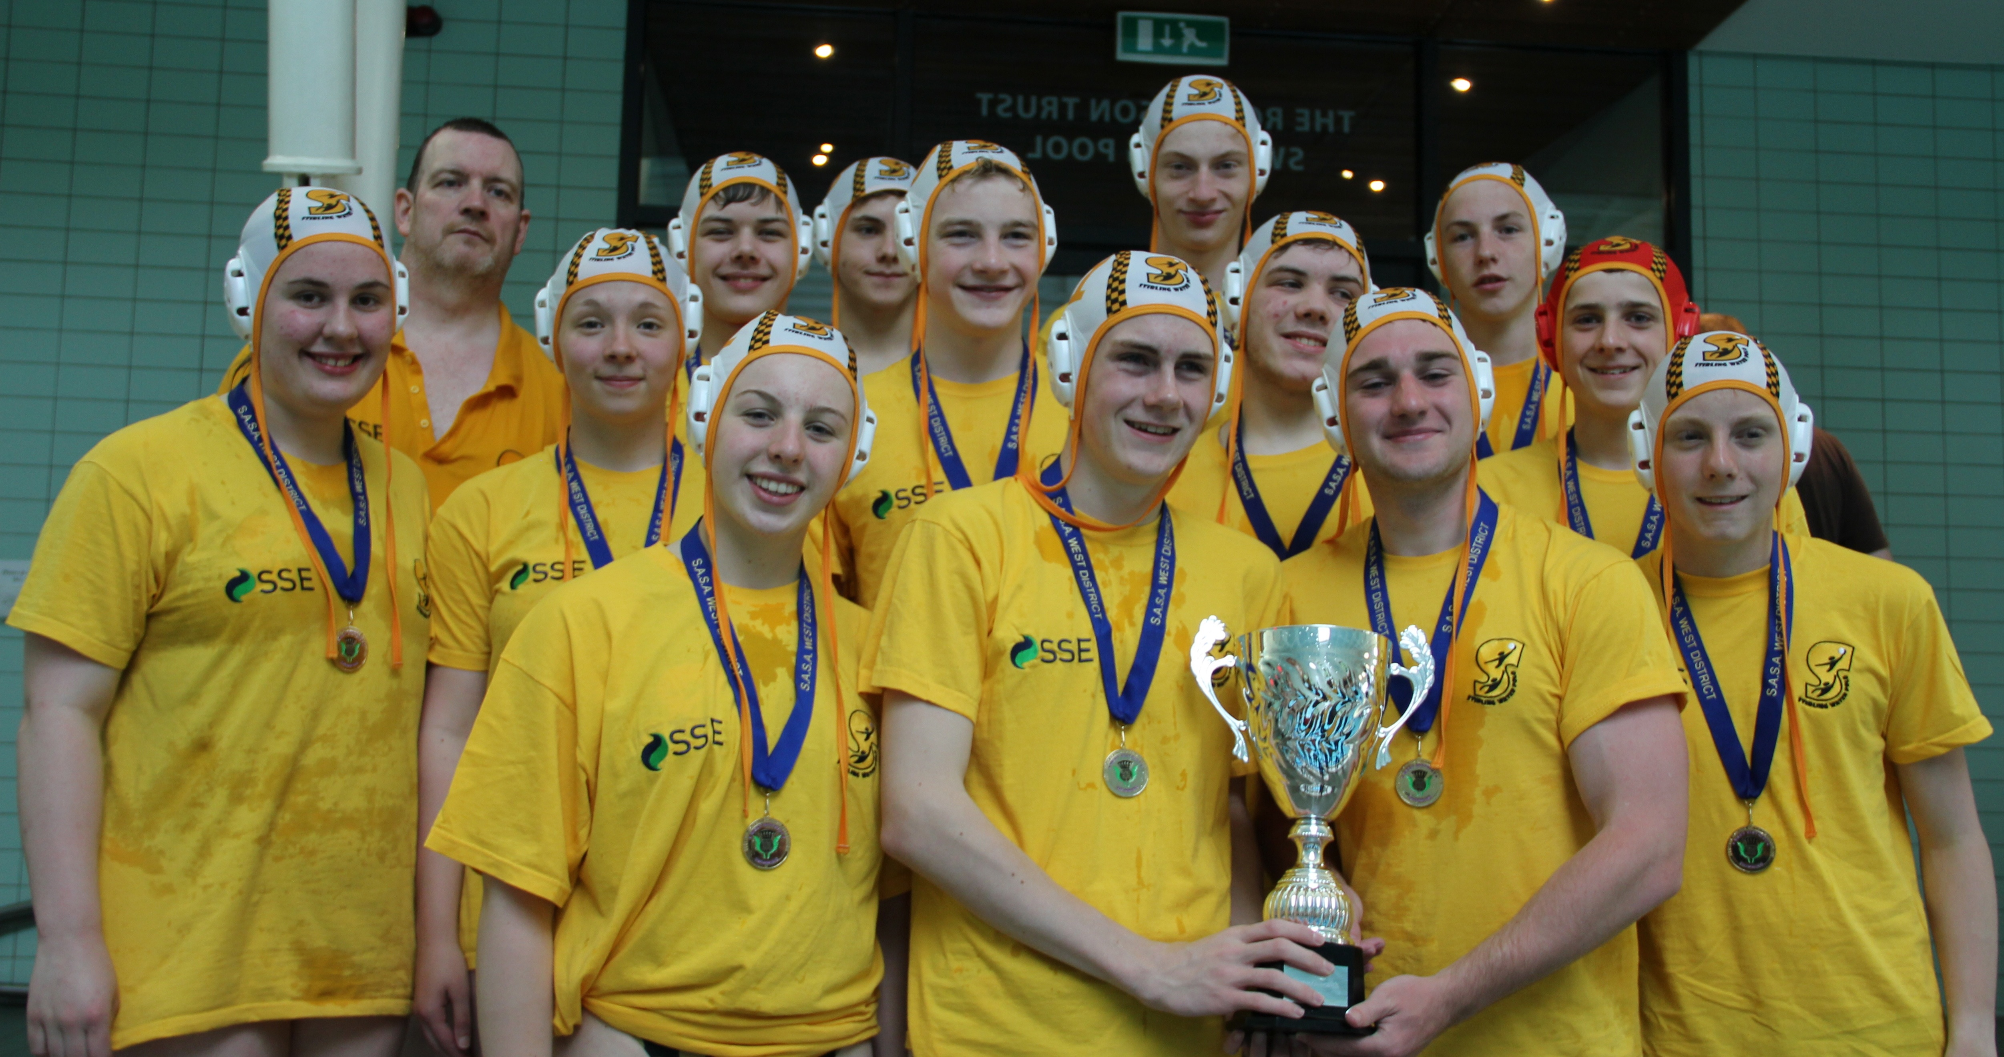

Teams (scorers) Elliot Harris, Stuart Myles, Cameron Harris (8), Ben Bowman, Lewis Aitchison (1), Sara Morrison, Skye Campbell, Jack McKenzie, Lewis Goldie, Angus Cameron (3), Jamie Murray (3), Aisla Gordon, Reuben Bowman

Scottish Under 18 (1997+) ASA Inter Region Championships
Sheffield, 12/13 July 2014

Angus Cameron, Elliot Harris & Lewis Goldie were the Stirling players selected for this Tournament. As Scotland did not enter this Tournament last year, they were placed in Division 2 with five other teams. As the results show, some very close tussles.

Scotland 10 Wales 11 (3-3; 0-5; 4-1; 3-2)
Scotland 12 South East 11 (4-3; 4-4; 2-1 & 2-3)
Scotland 3 North Ravens 11
North East Reivers 12 Scotland 12

Scottish Water Polo Camp – Eger, Hungary
Lewis Aitchison and Reuben Bowmen were amongst 18 players to enrol in a Scottish Water Polo Camp in Eger, Hungary. .

The training and games were played mainly in the Eger Thermal Spa outdoor pool with two sessions in the adjacent Indoor pool. Two sessions were scheduled each day with training games played against the hosts. The Scottish players were well beaten in these and also against a touring American College team, all of which provided very competitive games.

The Squad also had the opportunity to watch some of the two sessions per day the Eger youngsters have during the summer and learn what it takes to reach the level they have through hard work.
Summer Camp - Barcelona
Lauren Dundee also enrolled in a Water Polo camp whilst on holiday in the Barcelona region and enjoyed the experience and felt that much was learned.

Summer Arrangements

Our Training Sessions continue through the summer and it is important that everyone attends when they can. The League season for Under 18s as well as the continuation of the Under 16 League commences straight after the holidays and I would hope that everyone will be fit and ready to play.

Upcoming Fixtures

These are the various provisional fixtures for our various Teams:

Scottish National League - Under 18 (1997+)

Date
Time | Venue | Team 1 |  | Team 2
Sunday 9th March | 13:45 | NSA | Warrender | v | Kelpie
Sunday 21st September | 12:30 | NSA | Menzieshill | v | Kelpie
Saturday 4th October | 14:00 | TISC | Kelpie | v | Portobello
Sunday 19th October | 12:30 | NSA | Kelpie | v | Hamilton
Saturday 1st November | 18:45 | RCP | Kelpie | v | Dunfermline
Saturday 8th November | 18:45 | RCP | Portobello | v | Kelpie
Saturday 15th November | 18:45 | RCP | Kelpie | v | Warrender
Sunday 23rd November | 12:30 | NSA | Dunfermline | v | Forth Valley
Saturday 29th November | 15:15 | TISC | Kelpie | v | Menzieshill
Sunday 7th December | 12:30 | NSA | Hamilton | v | Kelpie

Scottish National League - Under 16 (1999+)
There are a couple of outstanding games to be played before the League is split. Having won all but one of our games and drawn the other we will be in the top 4 (same as last year)

The following is the provisional schedule and the dates should be kept clear. Confirmation of fixtures will be issued when known

Date | Time | Venue | Team 1 |  | Team 2
Sunday 14th September | 12:30 | NSA | 2nd | v | 4th
Sunday 14th September | 13:45 | NSA | 1st | v | 3rd
Saturday 20th September | 17:30 | RCP | 1st | v | 2nd
Saturday 20th September | 18:45 | RCP | 4th | v | 3rd
Sunday 5th October | 12:30 | NSA | 3rd | v | 2nd
Sunday 5th October | 13:45 | NSA | 4th | v | 1st
Saturday 1st November | 14:00 | TISC | 2nd | v | 4th
Saturday 1st November | 15:15 | TISC | 1st | v | 3rd
Saturday 8th November | 14:00 | TISC | 1st | v | 2nd
Saturday 8th November | 15:15 | TISC | 4th | v | 3rd
Saturday 15th November | 14:00 | TISC | 2nd | v | 3rd
Saturday 15th November | 15:15 | TISC | 1st | v | 4th

Under 14 (2001+) Tournament
Only 1 scheduled to date but we are trying to get some friendly games arranged. Depending on availability we may be looking to take 2 Teams through.

Saturday 6 September 13.00 Carnegie Centre Dunfermline

As ever, I am available before and after Sunday training to answer any questions – also feel free to contact me by e-mail – daviddalziel23@aol.com

Regards

David Dalziel
Water Polo Coach

http://www.stirlingswimming.co.uk

http://www.facebook.com/StirlingWaterPolo

Twitter - @StirlingWaterPolo

